**FRD- Functional Requirements Document**

1. **The Current Business Problem:** Currently, XYZ organization is facing an efficiency gap with the current system which requires arduous data entry and does not efficiently manage the different data sets. The end-users using the application do not want to use the current system and is looking for a well-designed new application with ease in usage. The internal staffs using the system are not very tech savvy as well.
2. **The Proposed Solution:** XYZ Organization requires a software solution to manage and track the activities of old age people, volunteers, social workers, departments, and programs. The software should be cost-effective, robust, and reliable, with the ability to generate reports for senior management to optimize analysis and facilitate better decision-making. The system should provide an effective solution for managing and organizing information related to these individuals and entities, including the ability to track and record their activities. The system should also provide user accounts for authorized personnel to access and update this information, as well as any relevant documents or resources. The software should be easy to use and maintain, with a user-friendly interface and the ability to import and export data as needed.
3. **System(s) Impacted:** Internal system
4. **Assumptions/Dependencies/Key Decisions:**

* The current system is not web based or centralized
* Data is manually entered by end users
  + Customers Registration (Old Aged People)
  + Volunteers
  + Social Workers
  + Programs
* Programs/Event are communicated via e-mail
* Volunteers/support workers only provide the service of transportation to local program for aged people.
* Volunteers and Social workers must pass a pass background check prior to application getting approved
* Once application for Volunteers/Social workers is approved, only then can they be matched with Old Aged people within 20-mile radius
* Approval / rejection of application is communicated via email or push update for volunteers and social workers
* Requirement for senior citizens = 65 years and above.
* Once Volunteers/social workers are approved, they can be matched up to 5 times a month
* All Match take place on the 1st Monday of a given month; Volunteers and social workers have to provide confirmation via email or app by the 2nd Monday of the given month.
* Volunteers/ social workers must be at least 18 years in age

1. **Customer / Social Worker Matching Management Requirements**
   * 1. **‘Home’ Page**

The system shall provide a user interface that includes a hyperlink labeled "New Registration." When a user clicks on this hyperlink, the system shall display a registration page that allows a new user to register for the system as either a customer, volunteer, or social worker.

* + 1. **‘New User Registration’ Hyperlink Navigation**

The system shall provide a user interface that includes a hyperlink labeled "New User Registration." When a user clicks on this hyperlink, the system shall display a "New User Registration" page.

* + 1. **‘New User Registration’ Page**

The system shall provide a user interface that includes two hyperlinks labeled "Snr. Citizen" and "Volunteers/Social Worker." When a user clicks on either of these hyperlinks, the system shall display a respective registration page for either "Snr. Citizen" or "Volunteers/Social Worker." The "Snr. Citizen Registration Page" shall allow a senior citizen to register for the system, while the "Volunteers/Social Worker Registration Page" shall allow a volunteer or social worker to register for the system.

* + 1. **‘Snr. Citizen Registration’ Page**

System shall display the following data fields on ‘Snr. Citizen Registration Page’

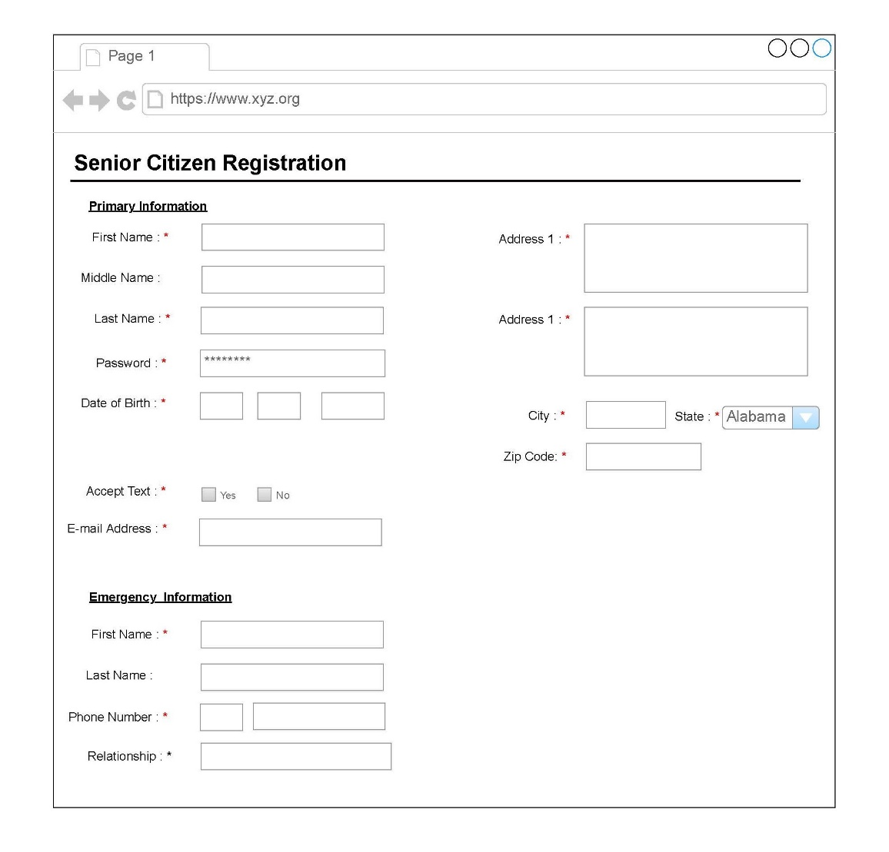

* + - 1. The system must allow a process for volunteers and social workers to pass background check prior to application approved
      2. The system must request all applicant qualifying question to validate basic requirements for participation:  
         . Senior citizen = 65-year-old, US citizen or Permanent Resident  
         . Volunteer/Social Worker = 18+, Valid Drivers License, No Criminal Background, No Drugs
      3. The system shall communicate approval or rejection of application via email or App) within 48hrs of back ground check.